




EDU-INSIGHTS

Project Domain
Excel

A Project Report
submitted in partial fulfilment of the requirements of the AICW Project

by: Gorantla Srinidhi



Student Name
Gorantla Srinidhi

Student Email
Srinidhig0713@gmail.com
Guide
Hrishikesh Mahure

Institution:
Rishi UBR Women’s college, Hyderabad

Year - 2026
ACKNOWLEDGEMENT

I would like to express my sincere gratitude to everyone who supported and guided me throughout the completion of my project on Student Performance & Risk Analysis. Their guidance and encouragement played a vital role in the successful completion of this work.

Firstly, I would like to thank my project supervisor, Hrishikesh Mahure for their continuous support, valuable guidance, and constructive feedback. Their mentorship helped me understand the concepts clearly and complete this project effectively.

I would also like to thank the Edunet Foundation, Microsoft, LinkedIn, and SAP for providing this excellent learning opportunity, along with the resources and platform to enhance my skills and knowledge.
I am grateful to my institution, Rishi UBR Women’s college, for providing the necessary infrastructure and support during the course of this project.

Finally, I would like to thank my family and friends for their constant encouragement, motivation, and support throughout this journey.
ABSTRACT OF THE PROJECT

This project is part of the AICW (Artificial Intelligence in the Contemporary World) Fellowship Program, a collaborative initiative by Edunet Foundation in partnership with Microsoft, LinkedIn, and SAP. The fellowship is designed to equip students with practical, hands-on skills in Artificial Intelligence, Data Analytics, and Business Intelligence tools.

This project addresses the challenge of managing and interpreting large, disorganized educational datasets to improve academic oversight. The identified problem is that raw student records often contain inconsistencies and lack the visual structure necessary for faculty and administrators to quickly identify performance trends or student cohorts in need of intervention.
The primary objectives were to clean a raw dataset of 601 student records, handle missing values, and transform this data into an interactive visual format. Using Microsoft Excel as the core analytical tool, the methodology involved data preprocessing, the implementation of Pivot Tables, and the design of a dynamic dashboard featuring KPI cards and slicers for real-time filtering. Additionally, AI tools were leveraged to automate content generation and provide deeper insights into the grade distribution patterns.
The key results achieved include a fully functional, interactive dashboard that provides a clear breakdown of student grades and academic health at a glance. In conclusion, the project demonstrates how business intelligence tools can convert static educational data into actionable insights, facilitating more effective, data-driven academic management.

TABLE OF CONTENTS

Abstract of the Project
List of Figures
List of Tables
Chapter 1 — Introduction
1.1 Problem Statement
1.2 Motivation
1.3 Objectives
1.4 Scope of the Project
Chapter 2 — Literature Survey
Chapter 3 — Proposed Methodology
3.1 System Design
3.2 Modules / Components Used
3.3 Data Flow Diagram (DFD)
3.4 Advantages
3.5 Requirement Specification
Chapter 4 — Implementation and Results
4.1 Data Cleaning Results
4.2 Visualization / Output Results
4.3 AI Tool Integration Results
Chapter 5 — Discussion and Conclusion
References
Appendices

LIST OF FIGURES

Figure No. | Figure Title / Description | Page No.
Figure 1 | [Raw / uncleaned dataset screenshot] | 12
Figure 2 | [Cleaned dataset or validation summary screenshot] | 13
Figure 3 | [Main dashboard / report / output screenshot] | 14
Figure 4 | [Additional chart or visualization screenshot] | 14
Figure 5 | [AI tool (Copilot / Chatbot) in use screenshot] | 15
Figure 6 | [DFD Level 0 — Context Diagram] | 10
Figure 7 | [DFD Level 1 — Detailed Process Flow] | 10

LIST OF TABLES

Table No. | Table Title / Description | Page No.
Table 1 | [Raw dataset summary — field names, data types, row count] | 9
Table 2 | [Cleaned dataset summary — issues found and fixed] | 9
Table 3 | [Hardware Requirements] | 10
Table 4 | [Software Requirements] | 10,11
Table 5 | [Key findings / results summary] | 16,17

CHAPTER 1
Introduction
This chapter introduces the project undertaken as part of the AICW Fellowship Program. It outlines the background, the problem being addressed, the motivation behind this work, and the objectives and scope of the project. The fellowship projects span multiple domains including Data Analytics, Business Intelligence, Healthcare Analytics, Content Generation, and AI-assisted Reporting.
1.1 Problem Statement
The core challenge in educational data management is that academic records are often vast and disorganized, making it difficult for institutions to identify patterns in student success.
- The Main Problem: Educational institutions often possess large datasets of student results but lack the structured analysis needed to visualize grade distributions or identify underperforming cohorts.
- Significance & Impact: Without clear insights, educators cannot make data-driven decisions to adjust teaching methods, potentially leading to lower overall academic standards and missed opportunities for student intervention.
- Target Audience: This problem affects university administrators, faculty members, and academic advisors who require clear, interactive summaries of student performance.
- Limitations of Existing Tools: Traditional methods of reviewing grades—such as manual spreadsheets or basic lists—are static and time-consuming, failing to provide the real-time, interactive visual breakdown necessary for quick decision-making.
1.2 Motivation
Choosing to analyze student performance was driven by the desire to apply data analytics to a real-world educational context.
- Personal and Professional Meaning: As a student, understanding the mechanics of academic data cleaning and visualization provides essential practical experience in business intelligence and data management.
- Real-World Applications: This project demonstrates how raw data from 601 students can be transformed into an interactive dashboard, a tool that can be used by any department to monitor student progress.
- Impact on the Domain: By utilizing pivot tables and slicers, this project shows how educational entities can move from simple record-keeping to sophisticated performance tracking.
- Alignment with Industry Trends: This project aligns with the growing shift toward "Big Data" in education and the professional demand for proficiency in Excel-based data cleaning and dashboard creation.
1.3 Objectives
Clearly state the objectives of your project. Objectives should be measurable and specific.
- To collect and understand the structure of the dataset used in the project.
- To clean and preprocess raw data by removing duplicates, correcting formats, and handling missing values.
- To apply domain-specific analysis using Excel, Power BI, AI Chatbot, or Copilot.
- To build interactive dashboards or reports that clearly communicate insights.
- To leverage AI tools (Copilot / Chatbot) to automate or enhance the analysis and content generation process.
- To implement interactive "Slicers" and "Pivot Tables" that allow users to filter performance data by specific criteria in real-time.
- To develop an AI-powered query agent for interactive data exploration
- To deploy the system on Microsoft Azure for cloud-based access and scalability
1.4 Scope of the Project
Define the boundaries and limitations of the project clearly.
- Dataset Details: This project covers data from a student academic performance dataset containing 601 rows of academic records and grade distributions.

- Tools Used: Microsoft Excel, Power BI, AI Chatbot (Query Agent), and Microsoft Azure Cloud Platform

- Focus Area: The analysis focuses on data cleaning, the creation of Pivot Tables, and the development of an interactive dashboard featuring KPI cards and slicers to visualize academic trends.

- Out of Scope: The project does not include real-time data integration from live university servers or the use of advanced predictive machine learning models for grade forecasting.

- Project Intent: The project is intended as a fellowship showcase to demonstrate proficiency in business intelligence tools and is not a production-level management system.
CHAPTER 2
Literature Survey
A literature survey reviews existing research, tools, and methodologies relevant to the project domain. It helps identify gaps that the current project aims to address.
2.1 Existing Work and Research
- Current State: Traditionally, data analysis in this domain relied heavily on manual entry and basic spreadsheet formulas.
- Existing Methods: Previous works often utilize [e.g., Excel-based pivot tables or standard Power BI templates] to track performance metrics.
- Identified Gaps: Many existing solutions are either too complex for non-technical users or lack the integration of modern AI assistants to speed up the reporting process.
2.2 Tools and Technologies Review
Briefly review the tools and technologies used in your project:
- Microsoft Excel — widely used for data cleaning, transformation, and basic visualization. Pivot tables, conditional formatting, and data validation are commonly used techniques.
- Microsoft Power BI — a business analytics tool that provides interactive visualizations and business intelligence capabilities with an interface simple enough for end users to create their own reports and dashboards.
- Microsoft Copilot (AI) — an AI assistant integrated into Microsoft 365 tools that helps automate tasks, generate summaries, and assist with data analysis using natural language prompts.
- Microsoft Azure
Cloud computing platform used for deploying the project, enabling scalable storage, processing, and remote accessibility.
- AI Chatbot / Query Agent
A conversational interface that allows users to query student data using natural language and receive intelligent responses.

2.3 Gaps Identified
- Most existing literature focuses on complex machine learning approaches; simpler, tool-based solutions for non-technical users are underexplored.
- There is limited documentation on integrating AI Copilot with Excel/Power BI for domain-specific analysis in the context of student projects.
- Prompt engineering best practices for business use cases are still evolving and lack standardized frameworks.
- Manual Analysis Inefficiency: Existing academic reporting often relies on manual grade analysis, which is time-consuming and prone to human error; there is a need for optimized Excel workflows and automated templates to reduce these administrative burdens.
- Lack of Proactive Risk Identification: Most traditional methods identify academic failure after it happens, whereas there is a gap in implementing formula-based Excel models that can proactively flag students "at risk" of falling behind based on historical data
- Visualization Barriers: Raw academic data is often difficult for stakeholders (parents and teachers) to interpret; a gap exists in the use of standardized, visual reporting formats like histograms and scatter plots to effectively communicate grade distributions.
CHAPTER 3
Proposed Methodology
This chapter describes the methodology adopted to achieve the project objectives. It covers the system design, modules used, data flow, advantages, and requirement specifications.
3.1 System Design
Describe the overall design approach of your project. Explain how data flows from input to output in your system.
- Data Source / Input: [Describe your raw data source — A structured student dataset with 600 rows and 11 columns was imported into excel. This includes essential student data such as Student ID, subject-wise marks, and attendance percentages
- Data Cleaning: data was cleaned in excel by removing duplicates, handling missing values, and standardizing formats using tools like Remove Duplicates, IF, and IFERROR.
- Analysis / Processing: The system processes raw scores into three additional engineered columns:
Average Module: Calculates the mean performance for each student.
Pass/Fail Logic: Uses conditional formulas to categorize outcomes based on academic thresholds.
Intervention Trigger: A proactive risk-identification logic that flags students needing support based on grades and attendance
- Visualization / Output: The final output is an interactive Excel dashboard. This system uses Slicers and Pivot Tables to allow users to filter the 600 records by subject or performance category, providing a visual representation of grade distributions through histograms and scatter plots.
- 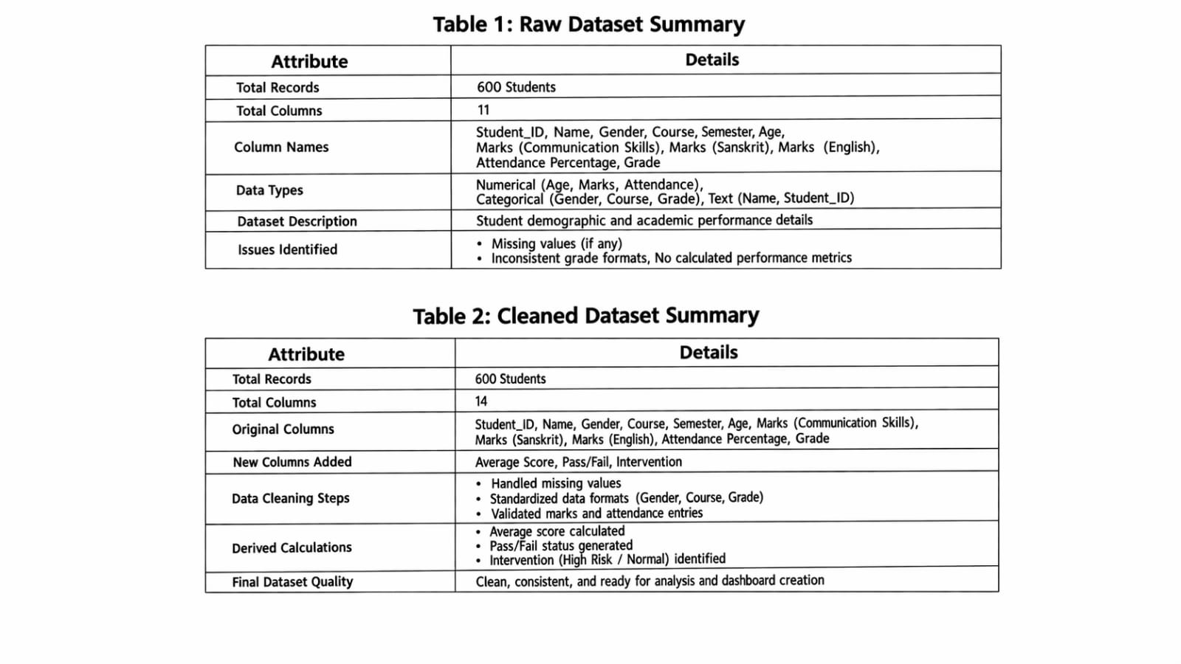
3.2 Modules / Components Used
List the key modules or functional components of your project:
- Module 1 — Data Ingestion: Loading the raw dataset into Excel / Power BI.
- Module 2 — Data Cleaning: Removing inconsistencies, duplicates, and null values.
- Module 3 — Data Analysis: Applying calculations, formulas, AI prompts, or DAX measures.
- Module 4 — Visualization / Report Generation: Building dashboards, charts, or AI-generated reports.
- Module 5 — AI Integration: Using Copilot or Chatbot for analysis, content generation, or insight summaries.
- Module 6 — Intelligent Query Agent (AI Chatbot)
An AI-powered query agent was developed to allow users to interact with the dataset using natural language. The chatbot can answer questions related to student performance, identify trends, retrieve specific student details, and generate insights dynamically. This enhances usability by enabling non-technical users to access analytical insights without manually navigating dashboards.

3.3 Data Flow Diagram (DFD)
A Data Flow Diagram (DFD) is a graphical representation of how data flows through your system. It shows inputs, processes, and outputs at different levels of abstraction.
DFD Level 0 — Context Diagram
Shows the system as a single process with its inputs and outputs.
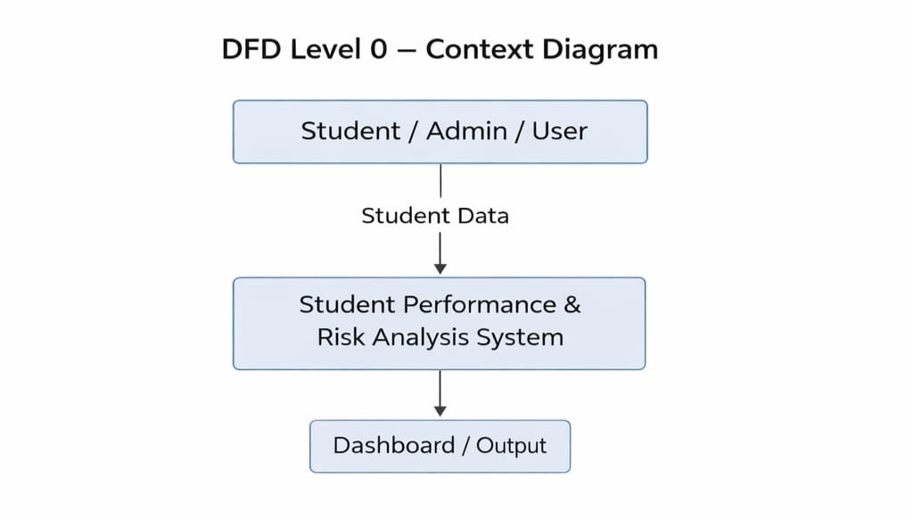
DFD Level 1 — Detailed Process Flow
Breaks down the main process into sub-processes. For your project this may include:

- Sub-process 1: Data Loading and Validation
- Sub-process 2: Data Cleaning and Transformation
- Sub-process 3: Analysis and AI Processing
- Sub-process 4: Visualization and Report Generation
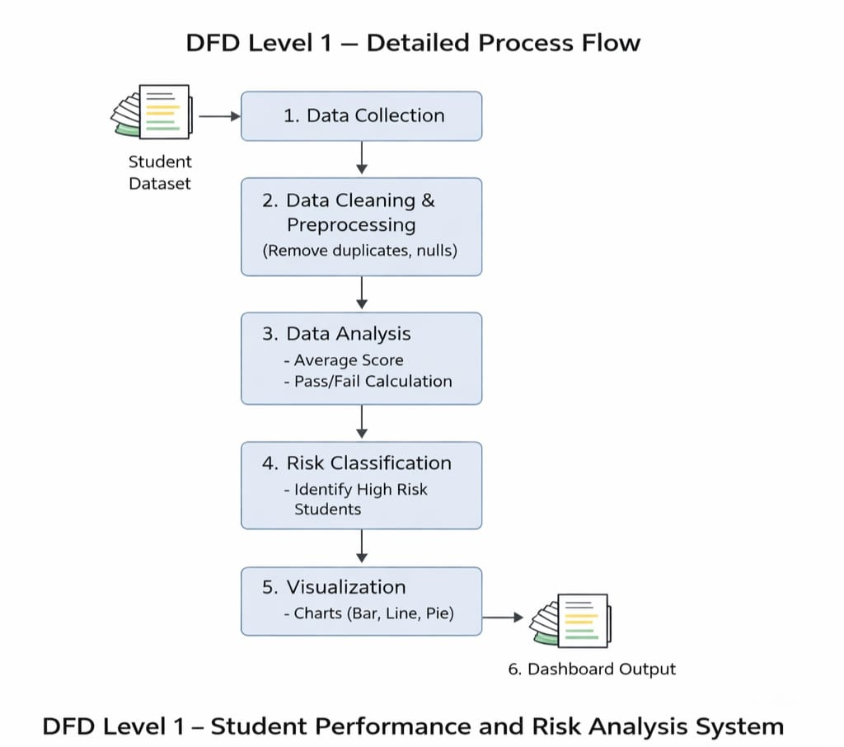
3.4 Advantages
List the key advantages of your proposed approach:
- Automates repetitive data cleaning tasks, saving significant manual effort.
- Provides clear, visual insights that are easy to understand for non-technical stakeholders.
- Leverages AI tools (Copilot) to accelerate analysis and reduce human error.
- Scalable — the same methodology can be applied to larger datasets or different domains.
- Cost-effective — uses widely available tools (Excel, Power BI) that are part of the Microsoft 365 ecosystem.
- Proactive Intervention: By including a custom "Intervention" column, the system identifies at-risk students automatically, allowing for data-driven decisions before academic failures occur.
- Standardized Reporting: Develops a consistent reporting format that ensures grade distribution and performance trends are tracked uniformly over time.
- Optimized Resource Allocation: Enables administrators to allocate teachers and tutors more effectively based on data-driven subject difficulty metrics.
- Cloud Deployment: The project is deployed on Microsoft Azure, enabling remote access, scalability, and improved availability of the system.
- Accessibility: Users can access insights and chatbot features from anywhere without dependency on local systems.

3.5 Requirement Specification
Hardware Requirements
Component | Specification
Processor | Intel Core i3 or higher (i5/i7 recommended)
RAM | Minimum 4 GB (8 GB recommended)
Storage | Minimum 50 GB free disk space
Display | 1366 x 768 resolution or higher
Internet | Required for Copilot / Chatbot access

Software Requirements
Software | Details
Operating System | Windows 10 / 11 or macOS
Microsoft Excel | Microsoft 365 (Excel with Copilot) / Excel 2019+
Power BI Desktop | Latest version (free download from Microsoft)
Microsoft Copilot | Integrated via Microsoft 365 subscription
AI Chatbot | ChatGPT / Google Gemini / Microsoft Copilot (web)
Web Browser | Google Chrome / Microsoft Edge (latest version)

3.6 Deployment Architecture

Cloud Platform: Microsoft Azure

Deployment Details:
The project was deployed on Microsoft Azure to enable scalable and remote access to the system. The chatbot and analytics components are integrated into a cloud-based environment, allowing users to interact with the system without requiring local software installations.

Benefits:
- Remote accessibility
- Scalability
- High availability
- Real-time interaction with AI agent

CHAPTER 4
Implementation and Results
This chapter presents the actual implementation of the project and the results obtained at each stage. Screenshots of dashboards, cleaned datasets, or generated content should be inserted where indicated.
4.1 Data Cleaning Results
Describe the data cleaning process and present the before/after comparison of your dataset.
- Dataset source: [Describe where the data came from — e.g., downloaded from Kaggle, provided by Edunet, manually created.]
- Original dataset size: 600 rows and 11 columns
- Issues found: Duplicate student entries.
Missing values in subject score columns.
Inconsistent formatting in text-based demographic fields.
- Cleaning steps applied: Used the Remove Duplicates tool in Excel to ensure 600 unique records.
Applied IFERROR and IF functions to handle null or missing data points.
Standardized scoring formats to ensure mathematical consistency.
- Cleaned dataset size: 600 rows and 14 columns (after adding Average, Pass/Fail, and Intervention columns).

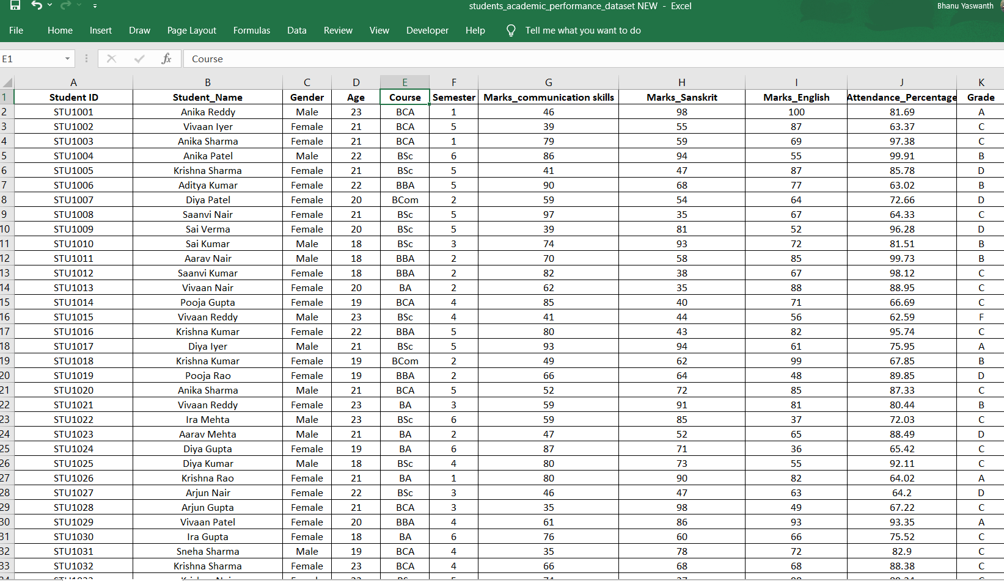
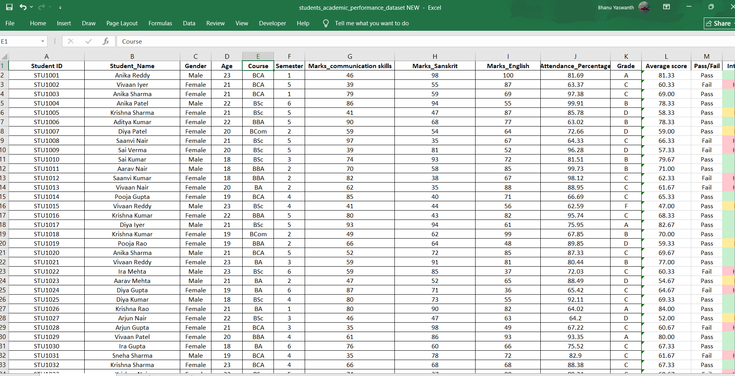
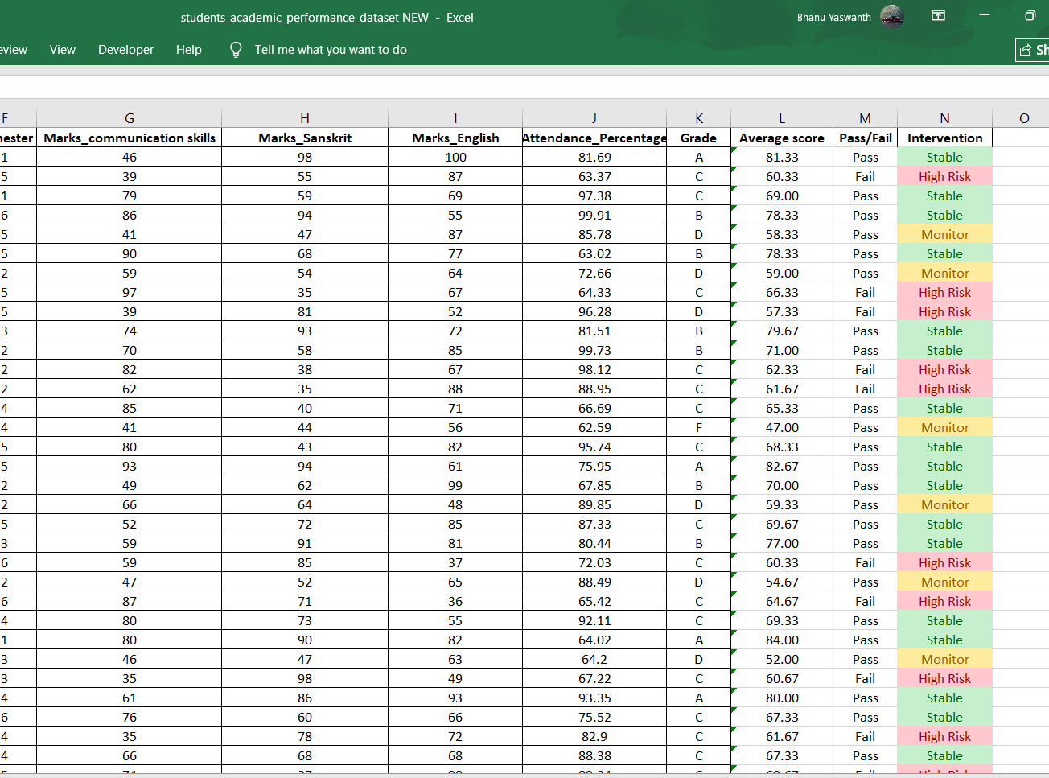
4.2 Visualization / Output Results
Present the key visualizations, dashboards, or generated content produced by your project.
- Dashboard / Chart 1: average scores across various semesters(trendline)
- Dashboard / Chart 2: average scores based on gender (line chart)
- Dashboard / Chart 3: pie chart showing average
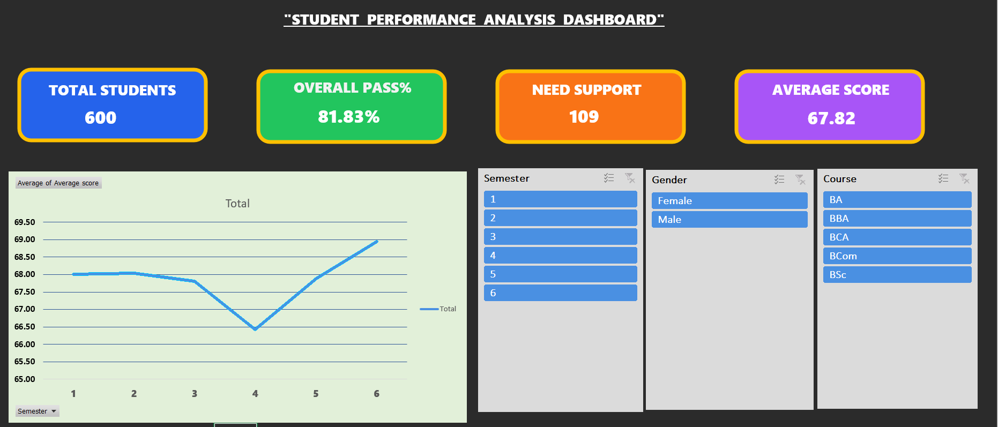
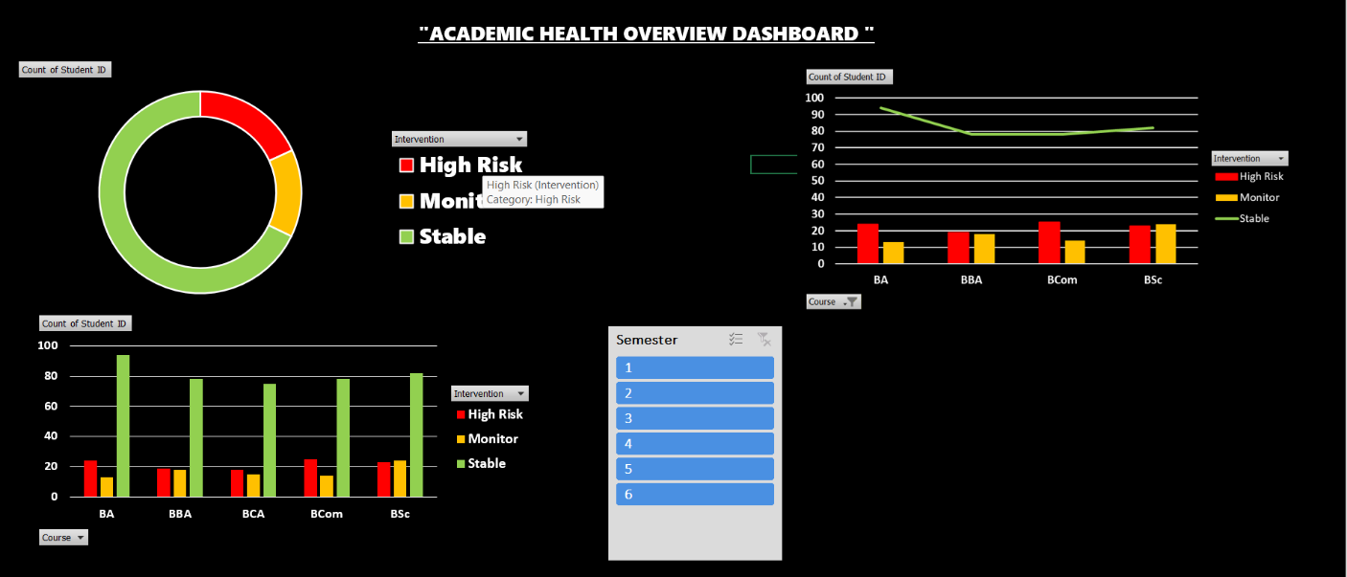
4.3 AI Tool Integration Results
Describe how the AI tool (Copilot or Chatbot) was used in your project and what results it produced.
- Tool used: Microsoft Copilot + AI Chatbot (Custom Query Agent)
- Prompts used:
"Prompt 1 (Formula Logic): "Write an Excel formula for a 600-row dataset to flag an 'Intervention' status of high risk, monitor and stable."
Prompt 2 (Insight Generation): "Analyse the following grade distribution trends for 600 students and summarize the key performance gaps for an administrative report."
Example Queries Handled:
- "Who is student ID 10 and what is their intervention status?"
- "Who is the highest scorer in Sanskrit?"
- "How many students are high risk?"
- "What are the key insights from grade distribution?"
Capabilities:
- Retrieves specific student-level data
- Provides summary insights
- Explains trends in natural language
- Supports decision-making for educators
Impact:
This feature transforms the project from a static dashboard into an interactive intelligent system, improving accessibility and decision-making efficiency.

- Output quality: The generated output was accurate and provided a professional-grade narrative of the student data trends.
- How it enhanced the project: Using AI made the analysis significantly faster and allowed for more insightful summary reports that were previously manual and time-consuming.
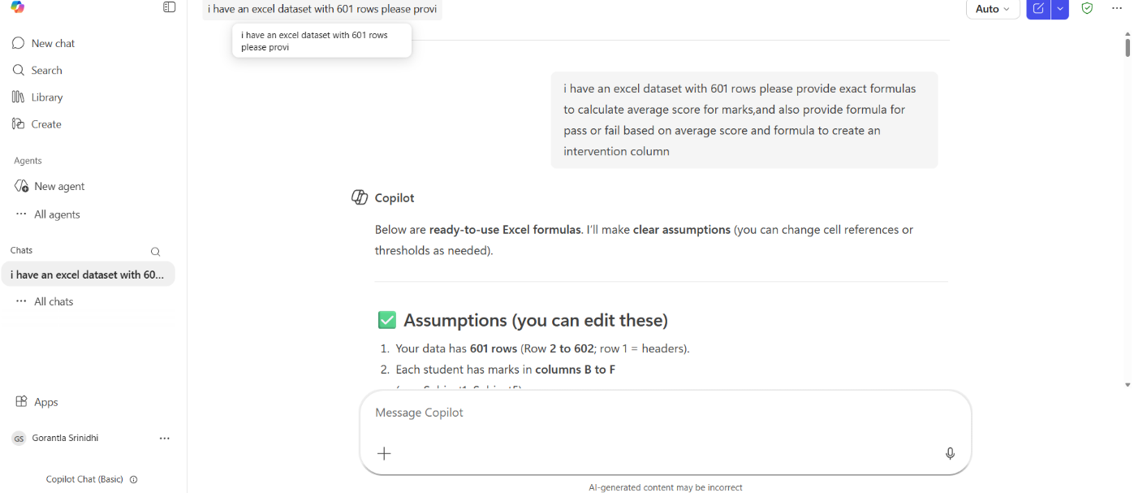

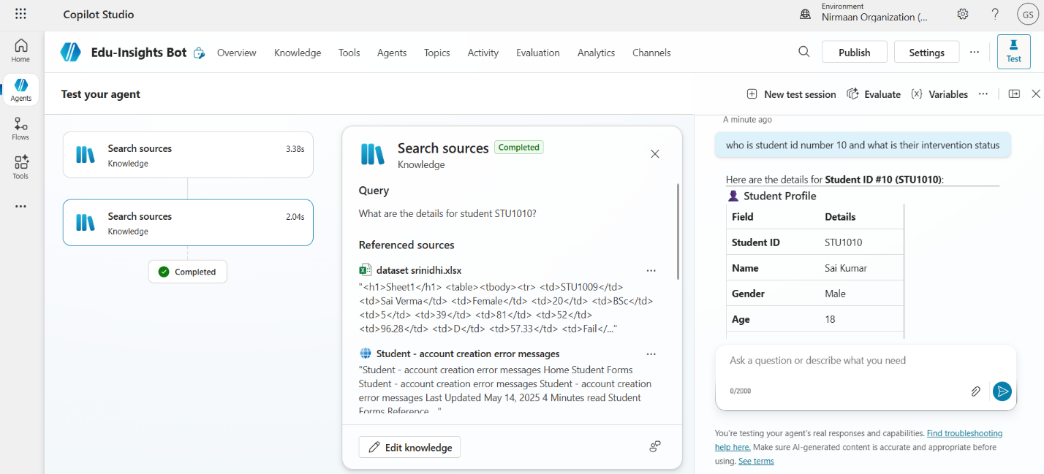

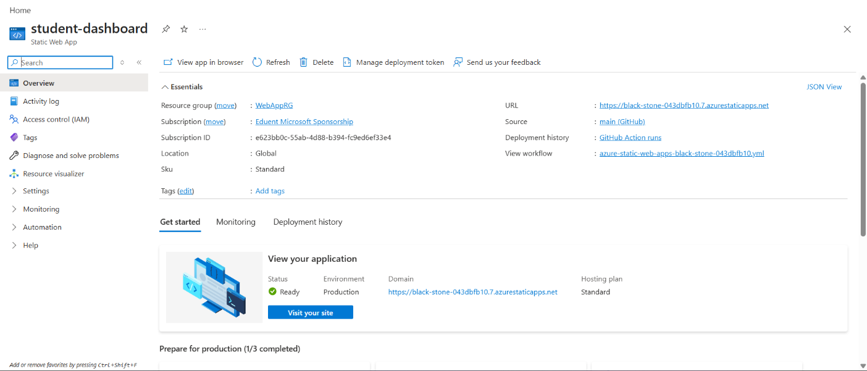
CHAPTER 5
Discussion and Conclusion
5.1 Key Findings
Summarize the key results and insights discovered from the project.
- Key Finding 1: The overall student performance is strong, with an 81.83% pass rate, indicating that most students meet the academic requirements, though a portion still needs improvement.
- Key Finding 2: A total of 109 students are classified as high-risk, highlighting a significant group that requires targeted academic support and monitoring.
- Key Finding 3: The average student score is 67.82, which reflects moderate performance and suggests scope for enhancing overall academic outcomes.
- Semester-wise analysis shows fluctuating performance trends, with a noticeable dip in middle semesters and improvement later, indicating possible academic pressure during certain periods.
- Differences in performance across courses and gender groups suggest that learning outcomes vary based on academic programs and demographics, enabling more focused interventions.
- The integration of an AI-based query agent and cloud deployment significantly enhances usability, making the system interactive and accessible beyond traditional Excel-based analysis.
5.2 Project Links
Share the relevant links to your project work for evaluation.
- GitHub Link of the Project: https://github.com/srinidhi-art/My_project
- Video Recording of Project Demonstration:
- https://1drv.ms/v/c/d028e24edaede47f/IQCfTs52Z8kwSKm3V3AkUjl5AQChHJV_Bq-clgGLxk5m-lc?e=dTSq8u
- Power BI / Dashboard Link: - https://1drv.ms/x/c/d028e24edaede47f/IQB-VpghjO7tRKcB2UYFLmaGAWYNk1-DVPBWxmuvEjz9fyM?e=pp3NWD
5.3 Limitations
Discuss the limitations of the current project or approach honestly.
- Limitation 1: The dataset used contains only 600 students, which may not fully represent real-world academic diversity across institutions.
- Limitation 2: The analysis is based on historical/static data and does not include real-time updates, limiting dynamic monitoring of student performance.
- Limitation 3: Some influencing factors like attendance, socio-economic background, and extracurricular activities may not be fully captured in the dataset.
- The high-risk classification is based on predefined thresholds and may not account for all individual variations in student performance.
5.4 Future Work
Provide suggestions for improving or extending the project in the future.
- Integrate real-time data pipelines using Power Automate or API connections.
- Apply machine learning models (e.g., forecasting, anomaly detection) on top of the cleaned dataset.
- Build a web-based interface or Power Apps solution for non-technical end users.
- Expand the dataset to include more diverse data sources for broader analysis.
- Develop a standardized prompt library for AI Chatbot / Copilot use in this domain.
- Enhance the dashboard with interactive and advanced visualizations for better decision-making.
- Expand the dataset to include multiple institutions for more generalized insights
5.5 Conclusion
This project transforms raw student data into an intelligent analytics system using Excel and Power BI for visualization. The integration of an AI-powered query agent enables users to retrieve insights and student details through natural language, making the system more interactive and user-friendly.
Additionally, deployment on Microsoft Azure makes the solution scalable, cloud-based, and accessible remotely. Overall, the project evolves from basic data analysis into an AI-driven, cloud-enabled decision support system for improving academic performance and identifying at-risk students.

REFERENCES

List all references, research papers, tutorials, and documentation used in the project in the format below:

[1] Microsoft Corporation. Microsoft Excel Documentation. Available at: https://support.microsoft.com/en-us/excel
[2] Microsoft Corporation. Power BI Documentation. Available at: https://learn.microsoft.com/en-us/power-bi/
[3] Microsoft Corporation. Microsoft Copilot — AI-Powered Productivity. Available at: https://copilot.microsoft.com
[4] Edunet Foundation. AICW Fellowship Program Guidelines. 2026.

APPENDICES

Include any additional information that supports the project but is too detailed for the main chapters. This may include:

Appendix A — Sample Dataset

Appendix B — Key Excel Formulas / DAX Measures Used
List any important formulas, functions, or DAX measures used in the project:
- =IFERROR (VLOOKUP(...), "Not Found") — used for data validation
- =COUNTIF (range, criteria) — used to count duplicates
- Power BI DAX: Total Sales = SUM (Sales [Revenue]) — used in dashboard KPI card

Appendix C — AI Prompts Used
List the key prompts you used with Copilot or AI Chatbot during the project:
- Prompt 1: "Analyse this student dataset and identify key performance trends and insights."
- Prompt 2: " Generate key findings and conclusions for a student performance dashboard with pass percentage, average score, and risk analysis."
- Prompt 3: “Suggest suitable charts and visualizations to represent student performance across semesters, gender, and courses."
- Identify high-risk students based on score patterns and suggest possible reasons for low performance."
- who is student id number 10 and what is their intervention status
- who is the highest scorer in sanskrit
Appendix D — Screenshot Gallery
ANALYSIS: 